# Sandbox Refresh

## Steps to be performed post sandbox creation.

1. Created a new FT2 sandbox from Production (last week).
2. Proess Builder Name: DA Create Chat Survey URL PB

Step: Create Survey URL V2

Set Field Value (Formula) – This URL still points to production.

1. Sanitize the following components (24/09/2019) – from **Neculai Florin Acalfoaie**

**Chatbot Related Visualforce Pages Deletion**:

1. DA_Chat_SnapIn (From Embedded Service Deployments DA_Chat_Core_General)
2. ChatInnogy_SnapIn (From Embedded Service Deployments SnapIn_ChatInnogy)
3. Chat_Solar_SnapIn (From Embedded Service Deployments DA_Chat_Core_Solar)
4. Chat_Core_SME_SnapIn (From Embedded Service Deployments DA_Chat_Core_SME)
5. Chat_SmartPlus_SnapIn (From Embedded Service Deployments DA_Chat_Core_SmartPlus)

Note – Aforesaid list are subject to change. Search all Chatbot related Visualforce page and delete them.

**Custom settings**:

1. Integration Administration – outbound > manage: Update Endpoint // change if main endpoint is pointing to prod otherwise not
2. Bit2Win Integration – outbound

**Custom Metadata Type**:

1. Next Action Setting: manage: **Update Action. NO MANUAL CHANGES REQUIRED
2. **Custom Labels - select id, name, value from customlabel** ** Update the Value.
3. DA_BillingURL
4. DA_PM_PowercloudURL
5. DA_PM_PowercloudURL1
6. DA_powercloud_URL
7. DA_PowerCloud_url1
8. DA_External_PowerCloudDE

**Outbound Messages**

1. All outbound urls has to make invalid/map new endpoints **update Endpoint URL

**Named Credentials** (has to check and map new endpoints here).

**Auth Providers –** change Endpoint URLs

**External Data Source –** change Endpoint URLs

**Connected Apps** (has to change with respect to new environment). - change callback URLs

Setup>Create>Apps>Connected apps (at bottom) > Select apps > Edit > Callback URL

**Ignore: **CIAM Frontend Connected APP –** Related urls

* https://openidconnect.herokuapp.com/callback
* https://pg1-www.click.eonenergy.com/my-login/login.html
* https://pg1-www.click.eonenergy.com/my-login/account.html
* https://pg1-www.click.eonenergy.com/my-login/transition.external.html
* https://cd-www.click.eonenergy.com/my-login/account.html
* https://cd-www.click.eonenergy.com/my-login/transition.external.html
* https://cd-www.click.eonenergy.com/my-login/login.html
* https://pg16-www.click.eonenergy.com/my-login/login.html
* https://pg16-www.click.eonenergy.com/en/my-login/account.html
* https://pg16-www.click.eonenergy.com/en/my-login/transition.html
* https://pg16-www.click.eonenergy.com/en/my-login/transition.external.html
* https://pg16-www.click.eonenergy.com/my-login/account.html
* https://pg16-www.click.eonenergy.com/my-login/transition.external.html
* https://lqa-www.click.eonenergy.com/my-login/account.html
* https://lqa-www.click.eonenergy.com/my-login/transition.external.html
* https://lqa-www.click.eonenergy.com/my-login/login.html
* https://da-pg16-www.eon.de/meineon/konto.html
* https://da-pg16-www.eon.de/meineon/transition.external.html
* https://da-pg16-www.eon.de/meineon/login.html
* https://int-www.eon.de/meineon/login.html
* https://int-www.eon.de/meineon/konto.html
* https://int-www.eon.de/meineon/transition.external.html
* https://int-www.eon.de/click-meineon/login.html
* https://int-www.eon.de/click-meineon/konto.html
* https://int-www.eon.de/click-meineon/transition.external.html
* https://uat-www.eon.de/de/meineonda/meine-uebersicht.external.html
* https://int-www.eon.de/de/meineonda/meine-uebersicht.external.html
* https://pg2-www.click.eonenergy.com/my-login/transition.external.html
* https://uat-www.eon.de/de/meineonda/meine-uebersicht.eondelogin.html
* https://da-pg16-www.eon.de/click-meineon/login.html
* https://da-pg16-www.eon.de/de/meineonda/meine-uebersicht.eondelogin.html

**Remote site settings to review \***\* Update Remote Site URL

Remove schedule monist report- unnecessary notifications for this scheduled report. **If any

**Remove schedule** Profile History **report- unnecessary notifications for this scheduled report.**

Scheduled Jobs > Delete all with Type: Report Run

**Marketing Cloud Steps to Follow for removal of Production Business Units-**

<https://help.salesforce.com/articleView?id=000350796&language=en_US&type=1&mode=1>

**Deactivate**:

Process Builder à JBSystem_Correspondence_c_Process

Flows à JBSystemFlow_Correspondence_c- V5

Flows – JbsystemFlow_case__c

From Process Automation Settings – Remove Default Workflow User from Marketing user and replace with cicd integration user.

1. Make all Users Inactive by running following script from Developer console.

Integration_User MuleSoft 0051v000006qHPWAA2

CIAM Integration User 0051v000006pBNwAAM

Srinath 0051v000006xMRMAA2

Hanamanth 0051v0000065Z3WAAU

Ranjith 0051v000009EjFkAAK

Nikhilesh 0051v000006oyzdAAA

Ajit 0051v0000065bDTAAY

Aakash 0051v000009i91NAAQ

Murali 0051v000009EjIKAA0

Ram 0051v00000600F4AAI

Sagar

List<User> users = [select id, isActive from user where isActive = true and usertype = 'Standard' and id not in ('0051v000009EjFkAAK','0051v000006qHPWAA2','0051v000006pBNwAAM','0051v000006xMRMAA2','0051v0000065Z3WAAU','0051v000006oyzdAAA','0051v0000065bDTAAY','0051v000009i91NAAQ','0051v000009EjIKAA0','0051v00000600F4AAI','0051v000005mgRkAAI','0050Y000002svh7QAA','0050Y000002wPo5QAE','0050Y000003lNSrQAM','0050Y000003lP6OQAU','0050Y000003m3RSQAY','0051v000005zz7jAAA','0050Y000002V5bwQAC') limit 200];

for(User u: users){

u.isActive = false;

}

system.debug('Users:'+ users.size());

update users;

### Certificate Key destruction

Platform Ops Notes\Generating Self Signed Certificate.txt

Assign permission set – Encryptrd data , platform encryption.

**Find the user > My Settings > Advanced user details > Permission Set Assignments > Edit Assignments

Self signed certificate

Certificate and Key Management > Create Self Signed Certificate

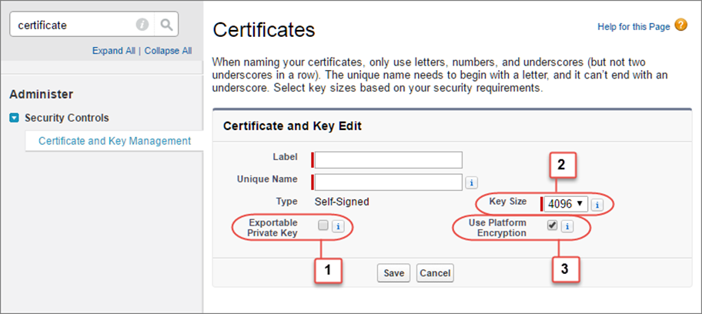

**Bring Your Own Key Process**

https://help.salesforce.com/articleView?id=security_pe_byok_script.htm&type=5&sfdcIFrameOrigin=null

https://help.salesforce.com/articleView?id=000315815&type=1&mode=1

Assign permission sets required for key generation to your profile.

in git bash change directory using, cd command

cd "C:\HCL Platform Operations Related\Encryption Related BP\UAT2 Keys\UAT Deterministic Key"

Download the script from the Salesforce Knowledge Base. Save it in the same directory as the certificate.

Run the script specifying the certificate name, like this: ./secretgen.sh PaSwBoxCert.crt

Replace this certificate name with the actual filename of the certificate you downloaded.

The script generates several files. Look for the two files that end with the .b64 suffix.

The files ending in .b64 are your base 64-encoded encrypted tenant secret and base 64-encoded hash of the plaintext tenant secret. You’ll need both of these files for the next step.

[Platform Encryption](https://eon--paswbox.my.salesforce.com/ui/setup/Setup?setupid=PlatformEncryption) > Key Management > Choose Tenant Secret Type: Data in Salesforce > Click on Bring your Own key

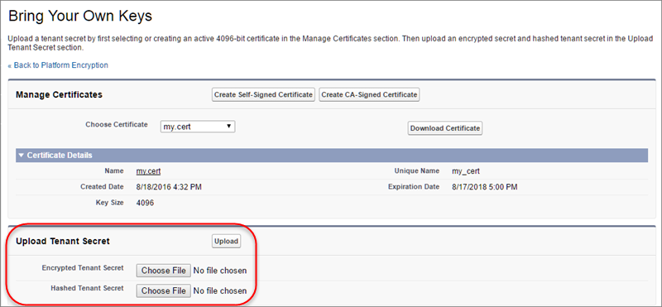

# Note: Ensure Encryption Statistics and Data Sync before deleting the Prod Keys.

***************************************************************

**Script –** Run the script to remove the production Metadata.



